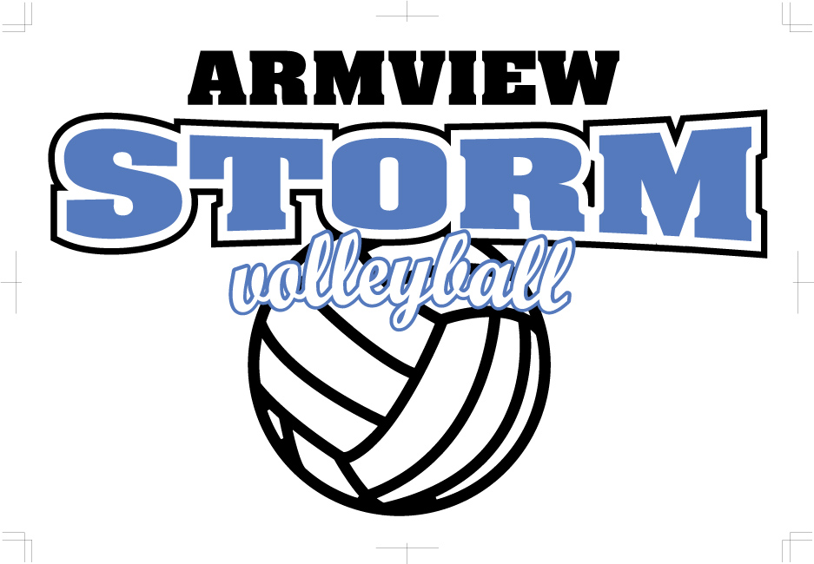
Parent Expectations
2020

Armview Storm Volleyball Club is committed to creating and upholding traditions of excellence through volleyball, focusing on responsibility and accountability. Everyone involved in the sport of volleyball is responsible for his or her own behavior whether on the court, the bench or in the stands.

As a Parent, I:

• Will remain in the spectator areas during all games.

• Will not advise the coach on how to coach, who to put in the game and/or who to take out of the game.

• Will not coach my child from the sidelines during a game.
• Will respect and support the coaching and directing staff of Armview Storm Volleyball Club. They are volunteers and are donating their time and energy to girl's volleyball.
• Will respect the integrity of the officials and not advise them how to call the match.
• Will model sportsmanship for my child by treating all coaches, officials, tournament directors and players of either team with courtesy and respect.

• Will encourage hard work and honest effort that will lead to improved performance and participation.

• Will emphasize the cooperative nature of the sport.

• Will encourage athletes to participate in volleyball drug, tobacco and alcohol free.

• Will cheer for my child’s team.

• Will encourage my child to participate for enjoyment as well as competition.

• Will applaud good and fair play during matches.

• Will learn the rules of the game to help me better understand what is happening on the court.

• Understand that physical or verbal intimidation of any individual is unacceptable behavior

• Will be supportive of all attempts to remove verbal or physical abuse from organized volleyball activities, including foul language.

• Understand that conduct that is inappropriate as determined by comparison to normally accepted behavior is unacceptable.

• Will protect the ability to continue using a facility by following all the rules of the facility, such as no food or drinks in gym @ ESS.

• Will take any issues of concern to the coaching staff and/or directors of Armview Storm Volleyball Club.

• Will honor financial commitments.
• Will participate in club fundraisers and events knowing that these events contribute to low registration fees and, that many hands make light work.
• Will represent Armview Storm Volleyball Club in a respectful and appropriate manner.

Athlete: _____________________________________ Date: _____________________ (please print players name)
Parent:______________________________________ Signature: __________________________________ (please print)

** By signing this you understand that if these are not upheld there will be consequences as deemed appropriate**

